Manual Testing Plan for Final1

1. Set up window: when launching the file, a pop-up window will ask for opening the wallet file. Only files with extension “.wallet” can be opened

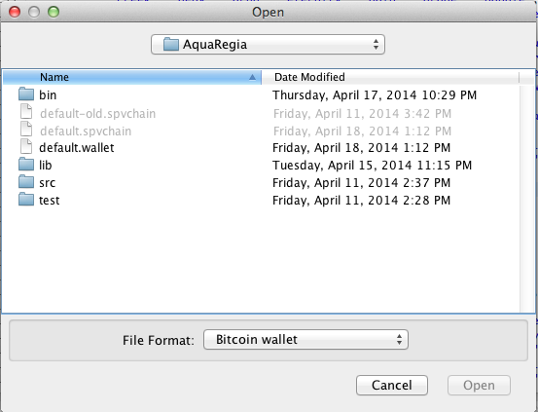

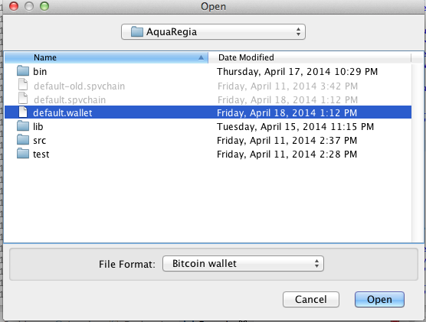

2. After opening up the default wallet, three different tabs will be shown as well as the current balance on the top left. For the “send” tab, after putting into address and Bitcoin amount, a confirmation window will pop up detailing the total amount, including the transaction fee

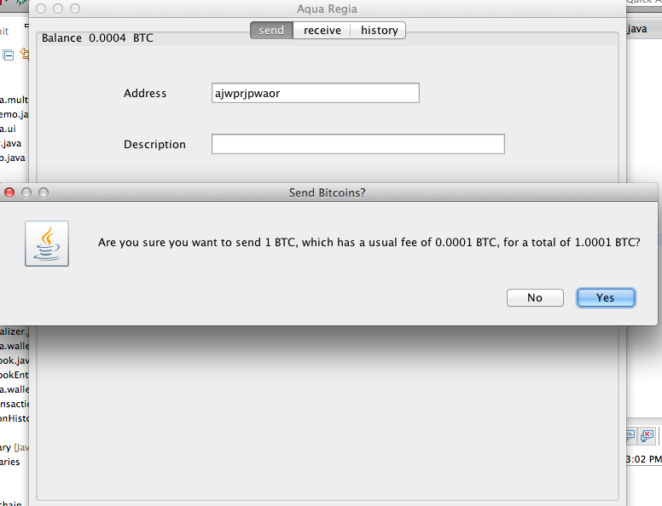

3. When the input address does not match Bitcoin’s address format, an error message will pop up

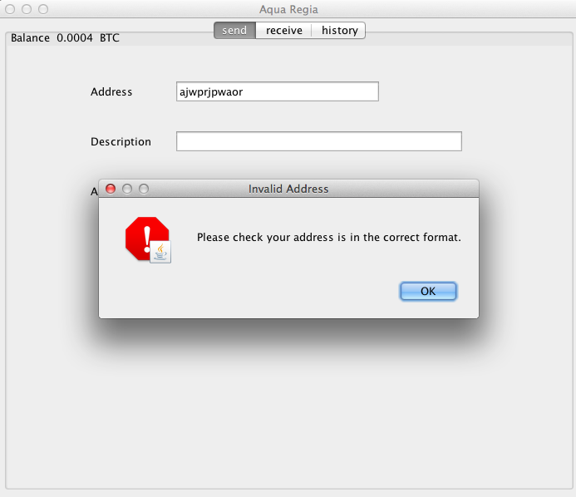

4. For the receive tab, a tab of all previously-generated addresses are shown

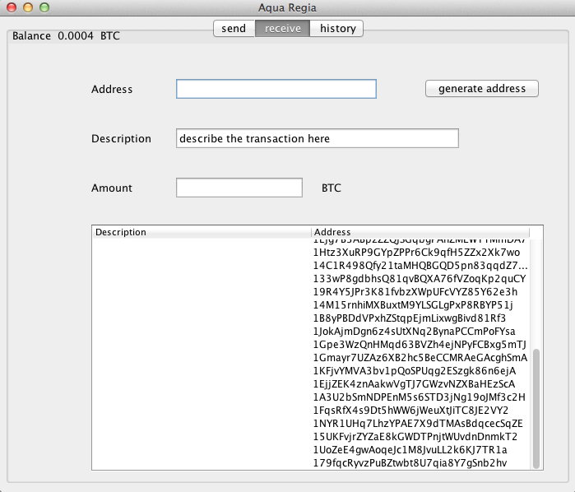

5. After pressing the “generate address” button, a new address is presented at the table bottom

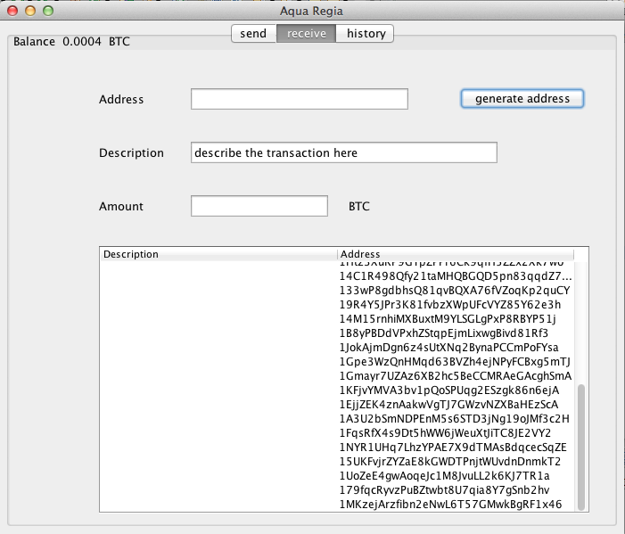

6. The “History” tab presents all transaction status, dates, description, amount and current balance

